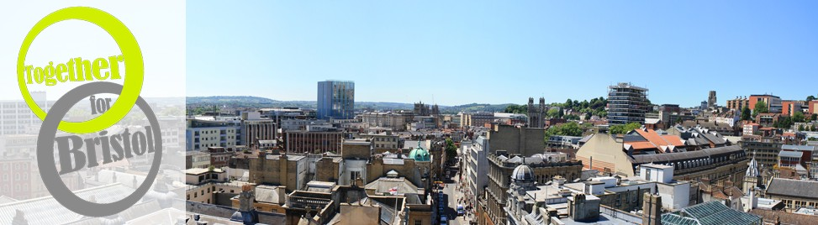
24th May 2013
Hello!

As you know, Churches Together in Greater Bristol has linked with Arise Bristol!, Evangelical Alliance and Bristol Networks, under the banner Together for Bristol, to organise a series of events during the year. The first was the very successful Pentecost Party in the Park on Sunday 19th May.

If you have had a stand at Spectrum at the Cathedral you should have received a letter from me about events later in the year – notably on 31st August – when Together for Bristol is organising “Going Deeper: Festival of Life” which will take place at the Colston Hall, from 12 noon. This event will build on the growing momentum of the Party in the Park, providing us with the opportunity to showcase all the amazing work that different churches and Christian organisations around the city are doing. There will be space for you to have a stall, as with previous Spectrum events, to publicise your work to thousands of people! There will be seminars, arts, music and more. The seminars will focus on the eight spheres of life: Arts and Media, Business and Workplace, Education and Young People, Family, Politics and Social Action, Sport and Health. Each will be led by specialists in the particular field and, as the title suggests, each will be explored more deeply, helping you to transform your community and Bristol as a whole. In the evening, at 6.00 p.m., there will be a celebration in the main hall including a wide range of worship styles and music and we will focus on local groups and choirs. It will be inspirational!

You can be involved by having a stall, helping with publicity and most of all by encouraging people to come along. We have been able to reduce the ticket price to just £5 for the whole event – including the evening celebration. Those who book stalls will be asked to pay £15, which will include two admission tickets. So we are now able to take firm bookings and I have enclosed a booking form which I would be grateful if you would complete and return to me as soon as possible and NOT LATER THAN 31st July. As you can imagine, this event involves a tremendous amount of work and any offers of help will be very, very welcome. We shall need stewards, programme sellers and lots of general help! Just send contact details of volunteers and we will be happy to contact them directly.

I’m looking forward to hearing from you!
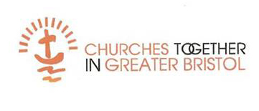
With best wishes,

Vena

