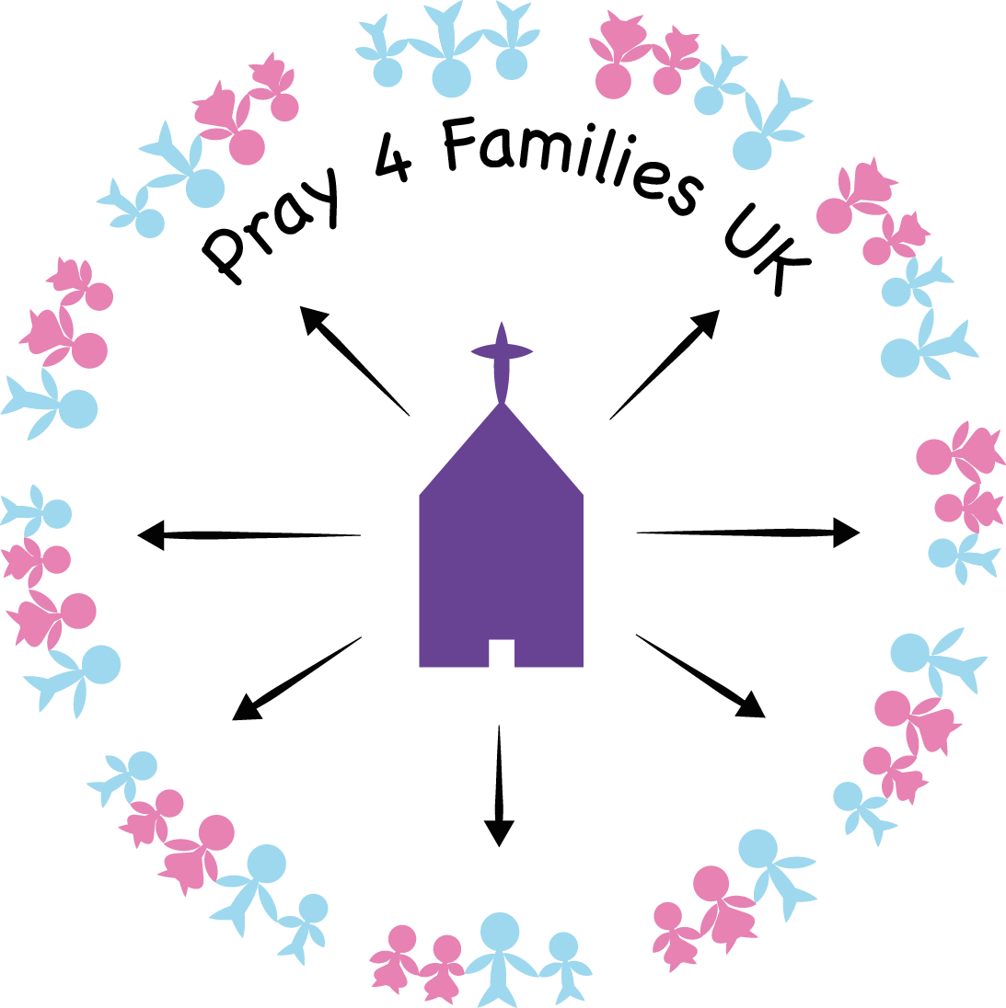
JUNE 2013
PRAYERPOINTS 5
‘It is easier for a camel to go through the eye of a needle than for someone who is rich to enter the kingdom of God’ Mark 10.25
GOD BLESS
- all marriages of one man and one woman
- all mothers and fathers
PLEASE PRAY FOR
- Missing children across the UK http://www.missingkids.co.uk/missing/
- http://makerunawayssafe.org.uk/church-resources
- Children’s care homes – that these are all homes of love and run by qualified staff with compassionate hearts for the children in their care
- Children affected by wrong exposure to internet/media (News feed 2**)
- Effects of Benefit Cap on families (News feed 3**)
- Homeless families –every 15 minutes a family becomes homeless – (**Prayer needs 4)
- Parents who are bereaved – for God’s comfort to encircle them
- Godly order to family life – Eph 5.21-6.3
- Children to be raised by parents with Godly principles by the power of the Holy Spirit
- Families UK wide to know Christ Jesus through prayer and action of the church
- Long-term commitment in relationships http://timeformarriage.org.uk
- Films/television productions/computer games – pray for purity, freedom from violence
- Families with complex needs – (Prayer needs 3**)
- Multiple birth parents that they receive the help they need
- Prayer triplets to form and pray for families in local areas across UK (see **home page)

Where there is an asterisk ** look on the website below for more details. Please use this website to help you to pray specifically.
Your prayers are so important to the well-being of UK families.
http://www.pray4familiesuk.co.uk

