GLOBAL AWARE CONFERENCE: THE SUSTAINABLE DEVELOPMENT GOALS

- How did the Church relate to the MDGs within their holistic & integral mission:
Launched in 2000 to make global progress on poverty, education, health, hunger and the environment, the United Nation’s Millennium Development Goals were a landmark for global commitment to a vision for ending poverty. They expired in 2015 and are replaced by the Sustainable Development Goals.
A number of churches engaged with the MDGs as a framework to help them flesh out their practical response to holistic and integral mission – for social action alongside proclamation.
In many parts of the world, churches were key actors in promoting the MDGs: in access to education, health, poverty reduction, women’s development, environmental protection, overcoming HIV/AIDS, Malaria, TB, promoting maternal and child mortality, and in working in partnership with others. They related the MDGs to the Gospel call to act on as well as speak out the Good News, citing scripture, such as: Luke 4: 18-19 (‘to bring good news to the poor...’); John 10:10 (‘I came that they might have life in all its abundance’); Matthew 25: 40 (‘...whatever you did for the least of these who are members of my family, you did it to me.’)

- What are the Sustainable Development Goals (SDG’s)?
Launched in September 2015 at the UN General Assembly, after years of intense negotiation and lobbying, the 17 SDGs are now established as the global goals to guide work on sustainable development, on poverty and climate justice, until 2030. They are interconnected and, unlike the MDGs, address themselves to industrialised as well as developing economies. This universality means that all countries will be required to plan and report on their progress. They also demonstrate the shared, joint ground between the environment and poverty agendas – but there will need to be trade offs (e.g. balancing carbon emissions against wealth creation).

- Opportunities for the Church to engage with the Sustainable Development Goals
As with the MDGs, the Church and other faith communities are recognised as having a key role, in implementation, but also in building values commitment and in monitoring and holding governments to account. The SDGs are about:
People – the goals are determined to end poverty and hunger, in all their forms and dimensions, and to ensure that all human beings can fulfill their potential in dignity and equality and in a healthy environment.
Planet – there is a determination to protect the planet from degradation, including through sustainable consumption and production, sustainably managing its natural resources and taking urgent action on climate change, so that it can support the needs of the present and future generations.
Prosperity – the goals have within them a desire to ensure that all human beings can enjoy prosperous and fulfilling lives and that economic, social and technological progress occurs in harmony with nature.
Peace – They recognise that fostering peaceful, just and inclusive societies that are free from fear and violence will enable people to flourish.
Partnership – as with the MDGs there is a clear articulated desire to work in partnership and the fuller documents highlight the essential role of the faith community.

- Archbishop of Canterbury’s statement on the Sustainable Development Goals
Archbishop of Canterbury Justin Welby said: "We must all now work together to redouble our efforts to banish global extreme poverty and inequality from our midst. When we recognise the God-given dignity in each and every person in our world, we are compelled to reach out to them in love, whatever the cost.”

- Questions for discussion
- What were the key contributions of the churches to the MDGs? What can we contribute to the SDGs?
- While they are all interconnected, which 3 goals do you think your own church should prioritise?
- Do these international instruments have anything to add to our understanding of holistic and integral mission?
- How do we generate a new kind of narrative that sees key theological ideas such as jubilee, forgiveness, lament and restored relationships at the heart of the goals?
- How might a movement be created around the new goals? (like Jubilee 2000)
- What will you do after today’s conference?
THE SUSTAINABLE DEVELOPMENT GOALS
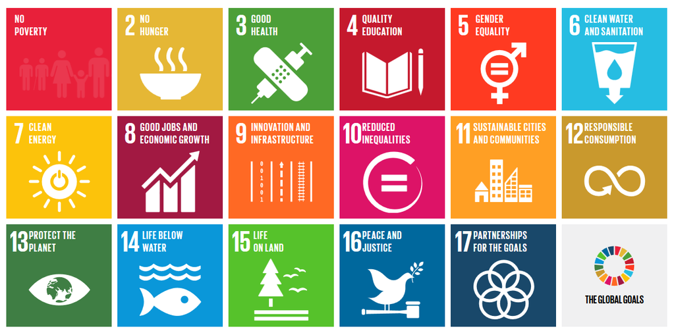

1: End poverty in all its forms everywhere
2: End hunger, achieve food security and improved nutrition, and promote sustainable agriculture
3: Ensure healthy lives and promote well-being for all at all ages
4: Ensure inclusive and equitable quality education and promote life-long learning opportunities for all
5: Achieve gender equality and empower all women and girls
6: Ensure availability and sustainable management of water and sanitation for all
7: Ensure access to affordable, reliable, sustainable, and modern energy for all
8: Promote sustained, inclusive and sustainable economic growth, full and productive employment and decent work for all
9: Build resilient infrastructure, promote inclusive and sustainable industrialization and foster innovation
10: Reduce inequality within and among countries
11: Make cities and human settlements inclusive, safe, resilient and sustainable
12: Ensure sustainable consumption and production patterns
13: Take urgent action to combat climate change and its impacts
14: Conserve and sustainably use the oceans, seas and marine resources for sustainable development
15: Protect, restore and promote sustainable use of terrestrial ecosystems, sustainably manage forests, combat desertification, and halt and reverse land degradation and halt biodiversity loss
16: Promote peaceful and inclusive societies for sustainable development, provide access to justice for all and build effective, accountable and inclusive institutions at all levels
17: Strengthen the means of implementation and revitalize the global partnership for sustainable development

Anglican Alliance for Relief, Development and Advocacy was established in 2011 to provide a platform for sharing information and skills and promoting collaboration across the Anglican Communion on development, humanitarian relief and advocacy on global issues, such as climate justice. The Anglican Alliance, along with the coalition Action2015, engaged in advocacy on the shaping of the SDGs and now works to spread awareness and engagement. www.AnglicanAlliance.org http://action2015.org

